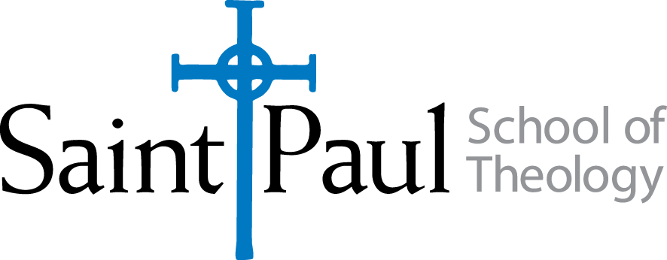

**PCM (#325 CAM- Preaching, Politics, and Social Action)**

Fall 2025

.5 Credit/No Prerequisites

Meets (on campus) (Tuesday, October 14, 2025)

***Instructor:*** Emanuel Cleaver III ***Contact info:*** drec3@sjumckc.org

***Course Description*** This course will examine the challenges of preaching justice and social action in the midst of the current political climate in the United States. Students will study how to examine scripture through the lens of liberation. We will also explore how to craft a sermon in light of sociopolitical realities facing our nation.

***Required Reading List (to be read prior to class meeting) “***Where Have All the Prophets Gone?: Reclaiming Prophetic Preaching in America” McMickle, Marvin; Pilgrim Press 2019, 978-0829818376

***Evaluation and Grading***

Course is offered for Credit/No Credit

Students who actively participate in all class activities, demonstrate evidence of having read the required course material prior to the class meeting, and submit the final assignment will receive credit for the course.

***Final Assignment (Due March 24th) A one-page reflection paper on what you learned during the class and how it will be applied to your ministry.***

***Attendance Policy***

Students must attend the on-campus class meeting in order to receive credit for the class. An absence of more than 1.5 hours of the on-campus meeting will result in a grade of “No Credit.”

***Policies***

The following policies will be followed in accordance with those stated in the Handbook:

* Attendance Policy
* Disability Accommodations Policy
* Plagiarism Policy and Penalties
* Extension Policy
* Copyright Compliance
* Inclusive Language