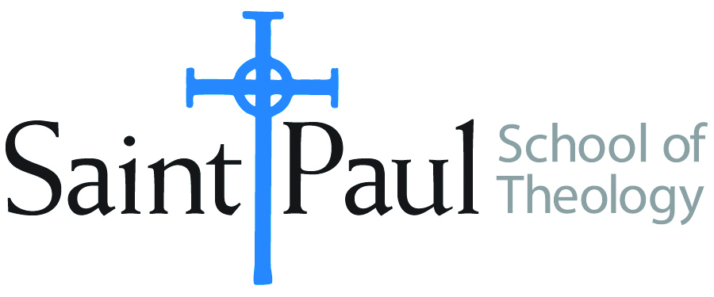**COURSE TEXTBOOK LIST INFORMATION**

|  |  |  |  |  |
| --- | --- | --- | --- | --- |
| ***FACULTY INSTRUCTIONS*** | |  | ***STUDENT INSTRUCTIONS*** | |
| *For each semester taught, faculty should complete and submit a new form each time the course is taught and returned. Forms are due by the first day of registration for a given term.*  ***DESKCOPY*** *– ordered by faculty and adjuncts USING THE* ***SAINT PAUL******AMAZON*** *ACCOUNT AND SPST CREDIT CARD. (OR, have Jennifer Smith order for you) at a $200 max for 1st time use of text per course.  IF you purchase yourself, note that we will NOT reimburse you for any tax or shipping paid by you, use the Expense Reimbursement Form, attach all actual / delivered receipt or invoices, return via email or mail, and this should be reimbursed with your first stipend payment (or next payroll payment)* | |  | *Students may acquire textbooks by ordering online via Amazon or other book retailer and having books shipped to them. Regardless of shopping / ordering method, students may check Cokesbury online for discount on text and certain texts may be sent free delivery.* | |
| **COURSE INSTRUCTOR(s)** | Kristen E. Kvam | | |
| **COURSE NUMBER & SECTION(s)** | THL 450 - Studies in a Selected Theologian: Elizabeth A. Johnson | | |
| **COURSE SEMESTER & YEAR** | Fall, 2025 | | |
| **DATE OF SUBMISSION** | March 22, 2025 | | |
|  |  | | |

|  |  |  |  |  |  |  |  |
| --- | --- | --- | --- | --- | --- | --- | --- |
| **REQUIRED TEXTBOOKS LIST** | | | | | | | |
| **BOOK TITLE** *and* **EDITION**  *(include subtitle if applicable)* | | **AUTHOR(S)** | *No. of*  **PAGES** *to be read* | **PUBLISHER** *and* **DATE** | *13-Digit* **ISBN**  *(without dashes)* | **LIST PRICE**  *(estimate)* | **DESK COPY** |
| 1 | *Consider Jesus: Waves of Renewal in Christology* | Elizabeth A. Johnson | 151 | Crossroad, 1992 | 9780824511611 | 17.00 |  |
| 2 | *Quest for the Living God: Mapping Frontiers in the Theology of God* | E. Johnson | 228 | Continuum, 2011 | 9781441174268 | 22.00 |  |
| 3 | *She Who Is: The Mystery of God in Feminist Theological Discourse* | E. Johnson | 300 | Crossroad, 1998 | 9780824519254 | 22.00 |  |
| 4 | Things Old and New: Essays on the Theology of Elizabeth Johnson | Zagano, and Tilley, ed. | 35-65 | Crossroad, 1999 | 8790824517977 | 5.00 |  |
| 5 | *“Statement on Quest for the Living God”* | Committee on Doctrine of the US Conference of Catholic Bishops | 21 | March, 2011 | <https://www.usccb.org/resources/statement-quest-living-god-sr-elizabeth-johnson> |  |  |
| 6 | Johnson’s Letter to US Bishops. Doctrine Committee | E. Johnson | 27 | National Catholic Reporter | <https://www.ncronline.org/> |  |  |
| 7 | *“Let a Female Speculate”* | E. Johnson | 25 | Religion News Service. August 17, 2014. | <https://religionnews.com/2014/08/17/let-female-speculate-full-text-sister-elizabeth-johnsons-talk-lcwr/> |  |  |
|  | **TOTAL** *Number of Pages to Be Read* | | 820 |

|  |  |  |  |  |  |  |  |
| --- | --- | --- | --- | --- | --- | --- | --- |
| **RECOMMENDED TEXTBOOKS LIST** | | | | | | | |
| **BOOK TITLE** *and* **EDITION**  *(include subtitle if applicable)* | | **AUTHOR(S)** | *No. of*  **PAGES** *to be read* | **PUBLISHER** *and* **DATE** | *13-Digit* **ISBN**  *(without dashes)* | **LIST PRICE**  *(estimate)* |  |
| 1 | *Dictionary of Feminist Theologies* | Russell and Clarkson, ed. |  | Westminster John Knox | 8970664229238 | 32.00 |  |
| 2 | *Abounding in Kindness: Writings for the People of God* | Elizabeth Johnson |  | Orbis. 2015 | 9781626981133 | 24.00 |  |
| 3 | *Friends of God and Prophets: A Feminist Theological Reading of the Communion of Saints* | E. Johnson |  | Continuum, 1998 | 9780826411983 | 40.00 |  |
| 4 | *Women, Earth, and Creator Spirit* | E. Johnson |  | Paulist, 1993 | 9780809134151 | 5.50 |  |
| 5 | *Ask the Beasts: Darwin and God* | E. Johnson |  | Bloomsbury, 2014 | 9781472903730 | 24.00 |  |
| 6 | *The Church Women Want: Catholic Women in Dialogue* | E. Johnson |  | Crossroad, 2002 | 9780824519797 | 15.00 |  |

Will there be **additional readings**, articles, websites for students to complete on the moodle course page? **_X__YES ___No**