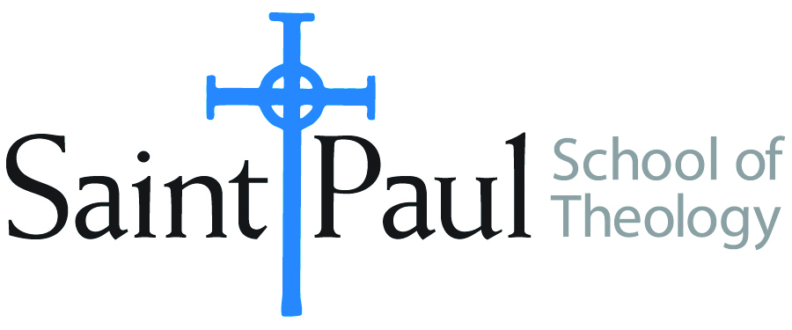**COURSE TEXTBOOK LIST INFORMATION**

|  |  |  |  |  |
| --- | --- | --- | --- | --- |
| **FACULTY INSTRUCTIONS** | |  | ***STUDENT INSTRUCTIONS***  ***(Both Campuses)*** | |
| For each semester taught, faculty should complete and submit a new form each time the course is taught and returned. Forms are due by the first day of registration for a given term. DESKCOPY – ordered by faculty and adjuncts at a $200 max for 1st time use of text per course.  Please fill out an Expense Reimbursement Form, attach all actual/delivered receipts, return via email or mail, and this should be reimbursed with your first stipend payment (or next payroll payment) | |  | *Students may acquire textbooks by ordering online via Amazon or other book retailer and having books shipped to them. Regardless of shopping / ordering method, students may check Cokesbury online for discount on text and certain texts may be sent free delivery.* | |
| **COURSE INSTRUCTOR(S)** | Richard Liantonio | | |  |
| **COURSE NUMBER & SECTION** | HBS 301 CAM | | |  |
| **COURSE NAME** | Introduction to Hebrew Bible | | |  |
| **COURSE SEMESTER & YEAR** | Fall 2025 | | |  |
| **DATE OF SUBMISSION** | 03/27/2025 | | |  |

|  |  |  |  |  |  |  |  |
| --- | --- | --- | --- | --- | --- | --- | --- |
| |  | | --- | | **REQUIRED TEXTBOOKS LIST** |   **BOOK TITLE** *and* **EDITION**  *(include subtitle if applicable)* | | **AUTHOR(S)** | # of **PAGES** *to be read* | **PUBLISHER** *and* **DATE** | *13-Digit* **ISBN**  *(without dashes)* | **LIST PRICE**  *(est)* |
| 1 | *The Old Testament*  *A Historical and Literary*  *Introduction to the Hebrew*  *Scriptures:* Fifth Edition | Michael D.  Coogan and  Cynthia R.  Chapman | 608 | Oxford  University  Press, 2025 | 978-0197768174 | $86.95 |
| 2 | *The New Oxford Annotated Bible,*  New Revised Standard Version, with  the Apocrypha, Fifth edition | Michael D. Coogan, et. al. | NA | Oxford  University  Press, 2018 | 978-0190276072 | $39.99 |
| 3 | *What They Don't Tell You: A*  *Survivor’s Guide to Biblical Studies, Second Edition* | Michael Joseph  Brown | 176 | Westminster John Knox | 978-0664235949 | $16.99**\*\*** |
| 4 | *Ancient Near Eastern Thought and the Old Testament: Introducing the Conceptual World of the Hebrew Bible*, Second Edition | John H. Walton | 384 | Baker Academic | 978-1540960214 | $17.93 |
|  | **TOTAL** *Number of Pages to Be Read* | | 1168 |

***\*\**Book is out of print, but can be bought as an e-book or check for used versions at https://www.addall.com**

|  |  |  |  |  |  |  |  |  |
| --- | --- | --- | --- | --- | --- | --- | --- | --- |
| |  | | --- | | **RECOMMENDED TEXTBOOKS LIST** |   **BOOK TITLE** *and* **EDITION**  *(include subtitle if applicable)* | | | **AUTHOR(S)** | # of **PAGES** *to be read* | **PUBLISHER** *and* **DATE** | *13-Digit* **ISBN**  *(without dashes)* | **LIST PRICE**  *(est)* |
| 1 | | *The Hebrew Bible: Feminist and Intersectional Perspectives* | Gale A. Yee (Editor) |  | Fortress | 978-1506425481 | 19.00 |
| 2 | | *Womanist Midrash: A Reintroduction to the Women of the Torah and the Throne* | Wilda C. Gafney |  | Westminster John Knox | 978-0664239039 | 23.49 (available on Audible) |
|  | | |  | | --- | | **RECOMMENDED TEXTBOOKS LIST – cont** |   **BOOK TITLE** *and* **EDITION**  *(include subtitle if applicable)* | **AUTHOR(S)** | # of **PAGES** *to be read* | **PUBLISHER** *and* **DATE** | *13-Digit* **ISBN**  *(without dashes)* | **LIST PRICE**  *(est)* |
| 3 | | *The Hebrew Bible: A Translation with Commentary* | Robert Alter |  | W.W. Norton | 978-0664239039 | 75.99 (available on Audible) |
| 4 | | *The Queer Bible Commentary*, Second Edition | Mona West (ed.) |  | SCM Press, 2022 | 978-0334060789 | $89 |
| 5 | | *Africa Bible Commentary: A One-Volume Commentary Written by 70 African Scholars* | Tokunboh Adeyemo (ed.) |  | Zondervan | 978-0310291879 | 31.49 |
| 6 | | *Women's Bible Commentary,* Third Edition: Revised and Updated | Carol A. Newson et. al (eds.) |  | Westminster John Knox | 978-0664237073 | 55.00 |
| 7 | | *How to Read the Bible* | James L. Kugel |  | Free Press | 978-0743235877 | 23.75 (available on Audible) |
| 8 | | *The Widening of God’s Mercy: Sexuality Within the Biblical Story* | Christopher B. Hays, Richard B. Hays |  | Yale, 2024 | 978-0300273427 | $28 (available on Audible) |
|  |  | | |  |