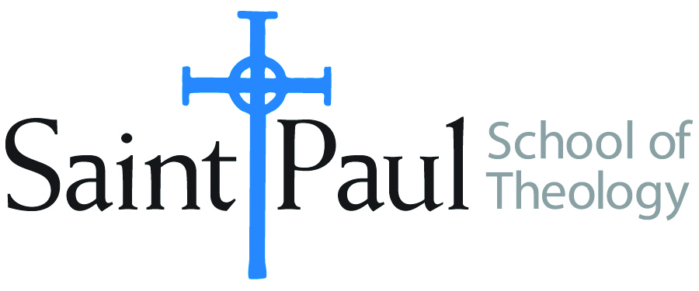 **COURSE TEXTBOOK LIST INFORMATION**

|  |  |  |  |  |
| --- | --- | --- | --- | --- |
| ***FACULTY INSTRUCTIONS*** | |  | ***STUDENT INSTRUCTIONS*** | |
| *For each semester taught, faculty should complete and submit a new form each time the course is taught and returned. Forms are due by the first day of registration for a given term.*  ***DESKCOPY*** *– ordered by faculty and adjuncts USING THE* ***SAINT PAUL******AMAZON*** *ACCOUNT AND SPST CREDIT CARD. (OR, have Jennifer Smith order for you) at a $200 max for 1st time use of text per course.  IF you purchase yourself, note that we will NOT reimburse you for any tax or shipping paid by you, use the Expense Reimbursement Form, attach all actual / delivered receipt or invoices, return via email or mail, and this should be reimbursed with your first stipend payment (or next payroll payment)* | |  | *Students may acquire textbooks by ordering online via Amazon or other book retailer and having books shipped to them. Regardless of shopping / ordering method, students may check Cokesbury online for discount on text and certain texts may be sent free delivery. Also check the SPST Library.* | |
| **COURSE INSTRUCTOR(s)** | **Richard Liantonio, Ph.D.** | | |
| **COURSE NUMBER & SECTION(s)** | ASR 412 SO/CAM | | |
| **COURSE NAME** | MACM Summative Seminar | | |
| **COURSE SEMESTER & YEAR** | Spring 2025 | | |
| **DATE OF SUBMISSION** | **12/05/24** | | |

|  |  |  |  |  |  |  |  |
| --- | --- | --- | --- | --- | --- | --- | --- |
| |  | | --- | | **REQUIRED TEXTBOOKS LIST** |   BOOK TITLE *and* EDITION  *(include subtitle if applicable)* | | AUTHOR(S) | # of pages *to be read* | PUBLISHER *and* DATE | *13-Digit* ISBN | LIST PRICE  *(est)* |
| 1 | The Widening of God's Mercy: Sexuality Within the Biblical Story | Christopher B Hays, Richard B Hays | 150 | Yale, 2024 | 978-0300273427 | $28 |
| 2 | Reforming Sodom: Protestants and the Rise of Gay Rights | Heather R. White | 186 | UNC, 2015 | 978-1469624112 | $37.50 |
| 3 | Our Lives Matter: A Womanist Queer Theology | Pamela R. Lightsey | 125 | Pickwick, 2015 | 978-1498206662 | $22/40 |
| 4 | A Manual for Writers of Research Papers, Theses, and Dissertations, Ninth Edition | Kate Turabian |  | University of Chicago, 2018 | 978-0226430577 | 22 |
|  | **TOTAL** *Number of Pages to Be Read* | | 461 |

|  |  |  |  |  |  |  |  |  |
| --- | --- | --- | --- | --- | --- | --- | --- | --- |
| |  | | --- | | **RECOMMENDED TEXTBOOKS LIST** |   BOOK TITLE *and* EDITION  *(include subtitle if applicable)* | | | AUTHOR(S) | # of pages *to be read* | PUBLISHER *and* DATE | *13-Digit* ISBN | LIST PRICE  *(est)* |
| 1 | The Queer Bible Commentary, Second Edition | | Mona West (ed.) |  | SCM Press, 2022 | 978-0334060789 | $89 |
| 2 | Hermeneia and Anchor Bible Commentary series | |  |  |  |  |  |
| 3 | Christianity, Social Tolerance, and Homosexuality: Gay People in Western Europe from the Beginning of the Christian Era to the Fourteenth Century | | John Boswell |  | University of Chicago, 2015 | **978-0226345222** |  |
| 4 | God and the Gay Christian | | Matthew Vines |  | Convergent Books | 978-1601425188 | 17 |
|  | | **TOTAL** *Number of Pages to Be Read* | |  |