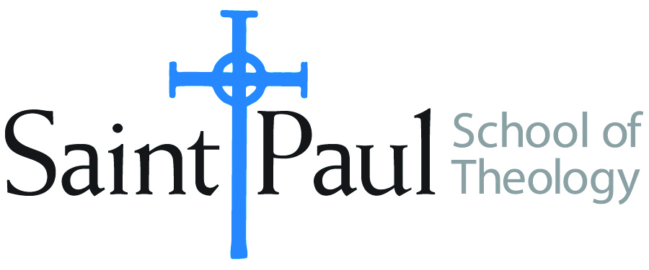**COURSE TEXTBOOK LIST INFORMATION**

|  |  |  |  |  |
| --- | --- | --- | --- | --- |
| ***FACULTY INSTRUCTIONS*** | |  | ***STUDENT INSTRUCTIONS*** | |
| *For each semester taught, faculty should complete and submit a new form each time the course is taught and returned. Forms are due by the first day of registration for a given term.*  ***DESKCOPY*** *– ordered by faculty and adjuncts USING THE* ***SAINT PAUL******AMAZON*** *ACCOUNT AND SPST CREDIT CARD. (OR, have Jennifer Smith order for you) at a $200 max for 1st time use of text per course.  IF you purchase yourself, note that we will NOT reimburse you for any tax or shipping paid by you, use the Expense Reimbursement Form, attach all actual / delivered receipt or invoices, return via email or mail, and this should be reimbursed with your first stipend payment (or next payroll payment)* | |  | *Students may acquire textbooks by ordering online via Amazon or other book retailer and having books shipped to them. Regardless of shopping / ordering method, students may check Cokesbury online for discount on text and certain texts may be sent free delivery.* | |
| **COURSE INSTRUCTOR(s)** | Casey Sigmon | | |
| **COURSE NUMBER & SECTION(s)** | Pre 401 HYB | | |
| **COURSE NAME** | Introduction to Preaching | | |
| **COURSE SEMESTER & YEAR** | Spring 2025 | | |
| **DATE OF SUBMISSION** | October 17, 2024 | | |

|  |  |  |  |  |  |  |  |  |  |
| --- | --- | --- | --- | --- | --- | --- | --- | --- | --- |
| |  | | --- | | **REQUIRED TEXTBOOKS LIST** |   BOOK TITLE *and* EDITION  *(include subtitle if applicable)* | | | | AUTHOR(S) | # of pages *to be read* | PUBLISHER *and* DATE | *13-Digit* ISBN | LIST PRICE  *(est)* |
| 1 | | Preaching as Paying Attention: Theological Reflection in the Pulpit | | Edward Foley | 160 | Liturgy Training Publications, 2021 | 978-1-61671-637-0 | 18.95 |
| 2 | | Preaching Jesus: Postcolonial Approaches | | Eunjoo Mary Kim | 162 | Rowman and Littlefield, 2024 | 978-1538192061 | 22 |
| 3 | | Preaching and Social Issues: Tools and Tactics for Empowering Your Prophetic Voice | | Leah D. Schade | 278 | Rowman and Littlefield, 2024 | 978-1538187616 | 25 |
| 4 | | The Four Pages of the Sermon, Revised and Updated: A Guide to Biblical Preaching | | Paul Scott Wilson | 288 | Abingdon, 2018 | 978-1501842399 | 30 |
|  | | **TOTAL** *Number of Pages to Be Read* | | | 888 |
| |  | | --- | | **RECOMMENDED TEXTBOOKS LIST** |   BOOK TITLE *and* EDITION  *(include subtitle if applicable)* | | | | AUTHOR(S) | # of pages *to be read* | PUBLISHER *and* DATE | *13-Digit* ISBN | LIST PRICE  *(est)* |
| 1 | Preaching the Word: Contemporary Approaches to the Bible for the Pulpit | | | Karoline Lewis |  | Westminster John Knox, 2023 | 978-0664266622 | 22 |
| 2 | The Future Shape of Christian Proclamation: What the Global South Can Teach Us About Preaching | | | Luiz C. Nascimento and Cleophus J. LaRue (Editors) |  | Cascade, 2020 | 978-1725252486 | 31 |
| 3 | Preaching the Manifold Grace of God: Vol. 2 Theologies of Preaching in the Early 21st Century | | | Ronald J. Allen (Editor) |  | Cascade, 2022 | 978-1725259621 | 34 |
|  | | | **TOTAL** *Number of Pages to Be Read* | |  |

Will there be additional readings, articles, websites for students to complete on the moodle course page? ___YES ___No