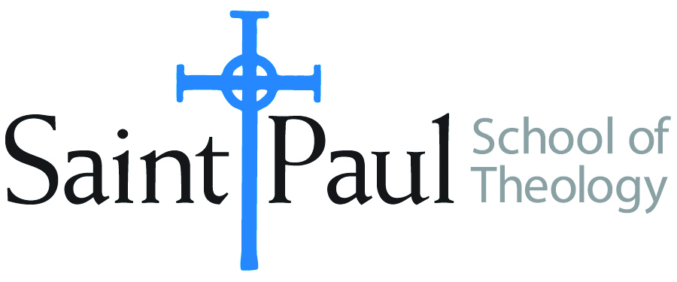
COURSE TEXTBOOK LIST INFORMATION

FACULTY INSTRUCTIONS |  |  | STUDENT INSTRUCTIONS  (Both Campuses)
For each semester taught, faculty should complete and submit a new form for every course and return to Melissa Whalen in the Academic Life office. Forms are due by the first day of registration for a given term. Desk copies for Teaching Assistants must be requested on this form. It is up to the publishers’ discretion whether or not to provide desk copies for teaching assistants. |  |  | Students may acquire textbooks by ordering online via Amazon Associate on our website and having books shipped to them. Regardless of shopping/ordering method, students may check Cokesbury online for discount on text and certain text may be sent free delivery.
COURSE INSTRUCTOR(S) | Elaine Robinson
COURSE NUMBER & SECTION | DST 330 ON
COURSE NAME | United Methodist Polity
COURSE SEMESTER &YEAR | Spring 2024
DATE OF SUBMISSION | October 20, 2023

REQUIRED TEXTBOOKS LIST
BOOK TITLE and EDITION  (include subtitle if applicable) |  | AUTHOR(S) | No. of  PAGES to be read | PUBLISHER and DATE | 13-Digit ISBN  (without dashes) | LIST PRICE  (estimate) | DESK COPY
1 | 2016 Book of Discipline of the United Methodist Church |  | ALL Skim for Famil-iarity | United Methodist Publishing House, 2016 | 9781501833236 | $24
2 | Quick and Easy Guide to United Methodist Polity | Burkholder and Elliott | As needed to define | Nashville: Foundry Books (GBHEM), 2018 | 9781945935121 | $24
3
4
5
6
7
 | TOTAL Number of Pages to Be Read |  | 250+

RECOMMENDED TEXTBOOKS LIST
BOOK TITLE and EDITION  (include subtitle if applicable) |  | AUTHOR(S) | No. of  PAGES to be read | PUBLISHER and DATE | 13-Digit ISBN  (without dashes) | LIST PRICE  (estimate) | DESK COPY
1
2
3
4

Special Instructions to Cokesbury:

